在CentOS 6.3下安装完Oracle 10g R2，重开机之后，你会发现Oracle没有自行启动，这是正常的，因为在Linux下安装Oracle的确不会自行启动，必须要自行设定相关参数，首先先介绍一般而言如何启动oracle。

**一、在Linux下启动Oracle**

登录到CentOS，切换到oracle用户权限

# su – oracle

接着输入：

$ sqlplus "/as sysdba"

原本的画面会变为  
SQL>

接着请输入  
SQL> startup

就可以正常的启动数据库了。

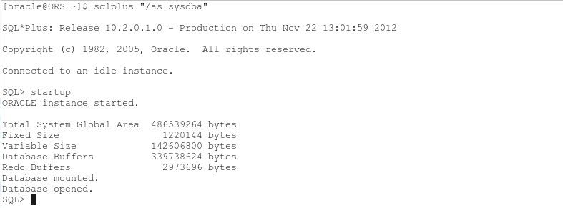

另外停止数据库的指令如下：  
SQL> shutdown immediate

**二、检查Oracle DB监听器是否正常**

回到终端机模式，输入：

$ lsnrctl status

检查看看监听器是否有启动

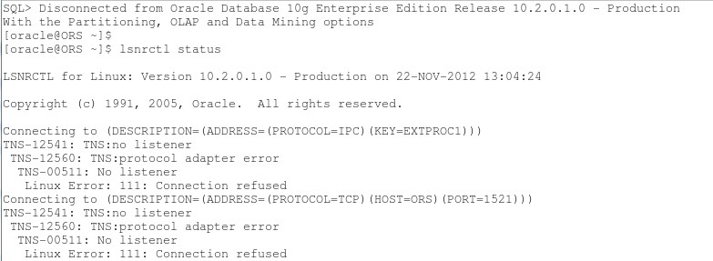

如果没有启动，可以输入：

$ lsnrctl start

启动监听器

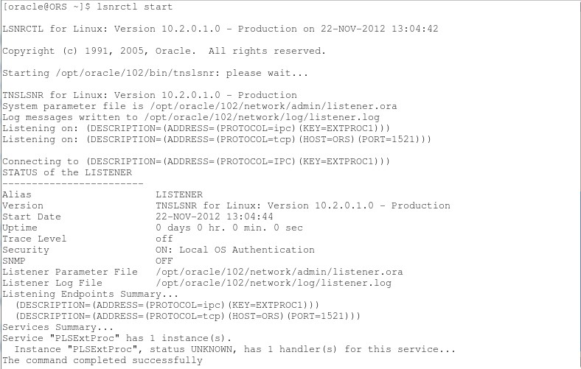

SQL> conn sys@orcl as sysdba

然后输入密码，sys以sysdba身份登入数据库。

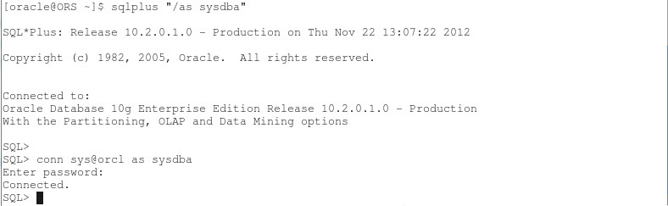

**三、启动emctl**

另外也可以发现http://localhost.localdomain:1158/em 目前是没有反应的，这边要另外启动，启动的指令如下：

$ emctl start dbconsole

这个指令运行时间较长，执行完的画面如下：

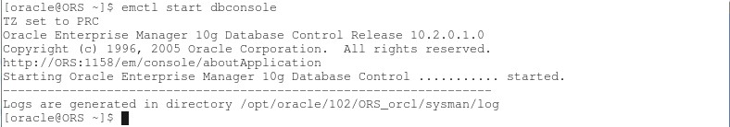

手动启动Oracle数据库完毕，下面创建系统自行启动Oracle的脚本。

**四、Oracle启动&停止脚本**

1. 修改Oracle系统配置文件：/etc/oratab，只有这样，Oracle 自带的dbstart和dbshut才能够发挥作用。

# vi /etc/oratab  
orcl:/opt/oracle/102:Y

*# Entries are of the form:*  
*#   $ORACLE_SID:$ORACLE_HOME:<N|Y>:*

2. 在 /etc/init.d/ 下创建文件oracle，内容如下：

[复制代码](javascript:void(0);)

#!/bin/sh

# chkconfig: 35 80 10

# description: Oracle auto start-stop script.

#

# Set ORA_HOME to be equivalent to the $ORACLE_HOME

# from which you wish to execute dbstart and dbshut;

#

# Set ORA_OWNER to the user id of the owner of the

# Oracle database in ORA_HOME.

ORA_HOME=/opt/oracle/102

ORA_OWNER=oracle

if [ ! -f $ORA_HOME/bin/dbstart ]

then

echo "Oracle startup: cannot start"

exit

fi

case "$1" in

'start')

# Start the Oracle databases:

echo "Starting Oracle Databases ... "

echo "-------------------------------------------------" >> /var/log/oracle

date +" %T %a %D : Starting Oracle Databases as part of system up." >> /var/log/oracle

echo "-------------------------------------------------" >> /var/log/oracle

su - $ORA_OWNER -c "$ORA_HOME/bin/dbstart" >>/var/log/oracle

echo "Done"

# Start the Listener:

echo "Starting Oracle Listeners ... "

echo "-------------------------------------------------" >> /var/log/oracle

date +" %T %a %D : Starting Oracle Listeners as part of system up." >> /var/log/oracle

echo "-------------------------------------------------" >> /var/log/oracle

su - $ORA_OWNER -c "$ORA_HOME/bin/lsnrctl start" >>/var/log/oracle

echo "Done."

echo "-------------------------------------------------" >> /var/log/oracle

date +" %T %a %D : Finished." >> /var/log/oracle

echo "-------------------------------------------------" >> /var/log/oracle

touch /var/lock/subsys/oracle

;;

'stop')

# Stop the Oracle Listener:

echo "Stoping Oracle Listeners ... "

echo "-------------------------------------------------" >> /var/log/oracle

date +" %T %a %D : Stoping Oracle Listener as part of system down." >> /var/log/oracle

echo "-------------------------------------------------" >> /var/log/oracle

su - $ORA_OWNER -c "$ORA_HOME/bin/lsnrctl stop" >>/var/log/oracle

echo "Done."

rm -f /var/lock/subsys/oracle

# Stop the Oracle Database:

echo "Stoping Oracle Databases ... "

echo "-------------------------------------------------" >> /var/log/oracle

date +" %T %a %D : Stoping Oracle Databases as part of system down." >> /var/log/oracle

echo "-------------------------------------------------" >> /var/log/oracle

su - $ORA_OWNER -c "$ORA_HOME/bin/dbshut" >>/var/log/oracle

echo "Done."

echo ""

echo "-------------------------------------------------" >> /var/log/oracle

date +" %T %a %D : Finished." >> /var/log/oracle

echo "-------------------------------------------------" >> /var/log/oracle

;;

'restart')

$0 stop

$0 start

;;

esac

[复制代码](javascript:void(0);)

3. 改变文件权限  
# chmod 755 /etc/init.d/oracle

4. 添加服务  
# chkconfig --level 35 oracle on

5. 需要在关机或重启机器之前停止数据库，做一下操作  
# ln -s /etc/init.d/oracle /etc/rc0.d/K01oracle   //关机  
# ln -s /etc/init.d/oracle /etc/rc6.d/K01oracle   //重启

6. 使用方法  
# service oracle start        //启动oracle  
# service oracle stop        //关闭oracle  
# service oracle restart     //重启oracle

7. 测试

**a. 开机自启动**

[复制代码](javascript:void(0);)

Last login: Mon Nov 26 19:57:06 2012 from 10.0.0.145  
[root@ORS ~]# su - oracle  
[oracle@ORS ~]$ sqlplus "/as sysdba"  
  
SQL*Plus: Release 10.2.0.1.0 - Production on Mon Nov 26 20:07:33 2012  
  
Copyright (c) 1982, 2005, Oracle.  All rights reserved.  
  
  
Connected to:  
Oracle Database 10g Enterprise Edition Release 10.2.0.1.0 - Production  
With the Partitioning, OLAP and Data Mining options  
  
SQL> set linesize 300;  
SQL> set pagesize 30;  
SQL> select * from scott.emp;  
  
     EMPNO ENAME      JOB              MGR HIREDATE         SAL       COMM     DEPTNO  
---------- ---------- --------- ---------- --------- ---------- ---------- ----------  
      7369 SMITH      CLERK           7902 17-DEC-80        800                    20  
      7499 ALLEN      SALESMAN        7698 20-FEB-81       1600        300         30  
      7521 WARD       SALESMAN        7698 22-FEB-81       1250        500         30  
      7566 JONES      MANAGER         7839 02-APR-81       2975                    20  
      7654 MARTIN     SALESMAN        7698 28-SEP-81       1250       1400         30  
      7698 BLAKE      MANAGER         7839 01-MAY-81       2850                    30  
      7782 CLARK      MANAGER         7839 09-JUN-81       2450                    10  
      7788 SCOTT      ANALYST         7566 19-APR-87       3000                    20  
      7839 KING       PRESIDENT            17-NOV-81       5000                    10  
      7844 TURNER     SALESMAN        7698 08-SEP-81       1500          0         30  
      7876 ADAMS      CLERK           7788 23-MAY-87       1100                    20  
      7900 JAMES      CLERK           7698 03-DEC-81        950                    30  
      7902 FORD       ANALYST         7566 03-DEC-81       3000                    20  
      7934 MILLER     CLERK           7782 23-JAN-82       1300                    10  
  
14 rows selected.  
  
SQL>

[复制代码](javascript:void(0);)

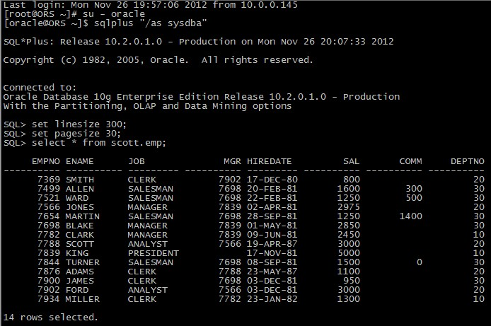

**b. service oracle stop**

[复制代码](javascript:void(0);)

SQL> Disconnected from Oracle Database 10g Enterprise Edition Release 10.2.0.1.0 - Production

With the Partitioning, OLAP and Data Mining options

[oracle@ORS ~]$ logout

[root@ORS ~]# service oracle stop

Stoping Oracle Listeners ...

Done.

Stoping Oracle Databases ...

Done.

[root@ORS ~]# su - oracle

[oracle@ORS ~]$ sqlplus "/as sysdba"

SQL*Plus: Release 10.2.0.1.0 - Production on Mon Nov 26 20:17:20 2012

Copyright (c) 1982, 2005, Oracle. All rights reserved.

Connected to an idle instance.

SQL> set linesize 300;

SQL> set pagesize 30;

SQL> select * from scott.emp;

select * from scott.emp

*

ERROR at line 1:

ORA-01034: ORACLE not available

SQL>

[复制代码](javascript:void(0);)

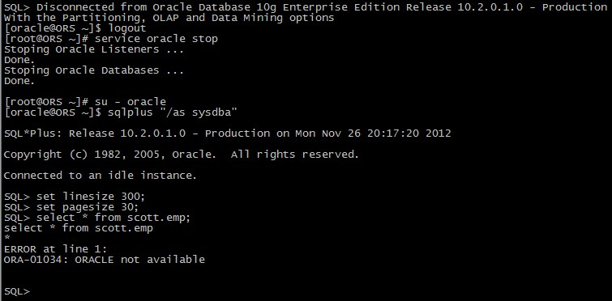

**c. service oracle start**

[复制代码](javascript:void(0);)

SQL> Disconnected

[oracle@ORS ~]$ logout

[root@ORS ~]# service oracle start

Starting Oracle Databases ...

Done

Starting Oracle Listeners ...

Done.

[root@ORS ~]#

[复制代码](javascript:void(0);)

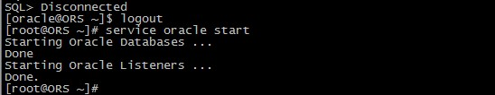

**d. service oracle restart**

[复制代码](javascript:void(0);)

[root@ORS ~]# service oracle restart

Stoping Oracle Listeners ...

Done.

Stoping Oracle Databases ...

Done.

Starting Oracle Databases ...

Done

Starting Oracle Listeners ...

Done.

[root@ORS ~]#

[复制代码](javascript:void(0);)

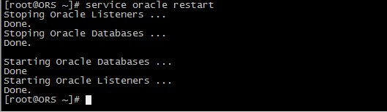

至此，Oracle服务启动&停止脚本与开机自启动设置完毕。